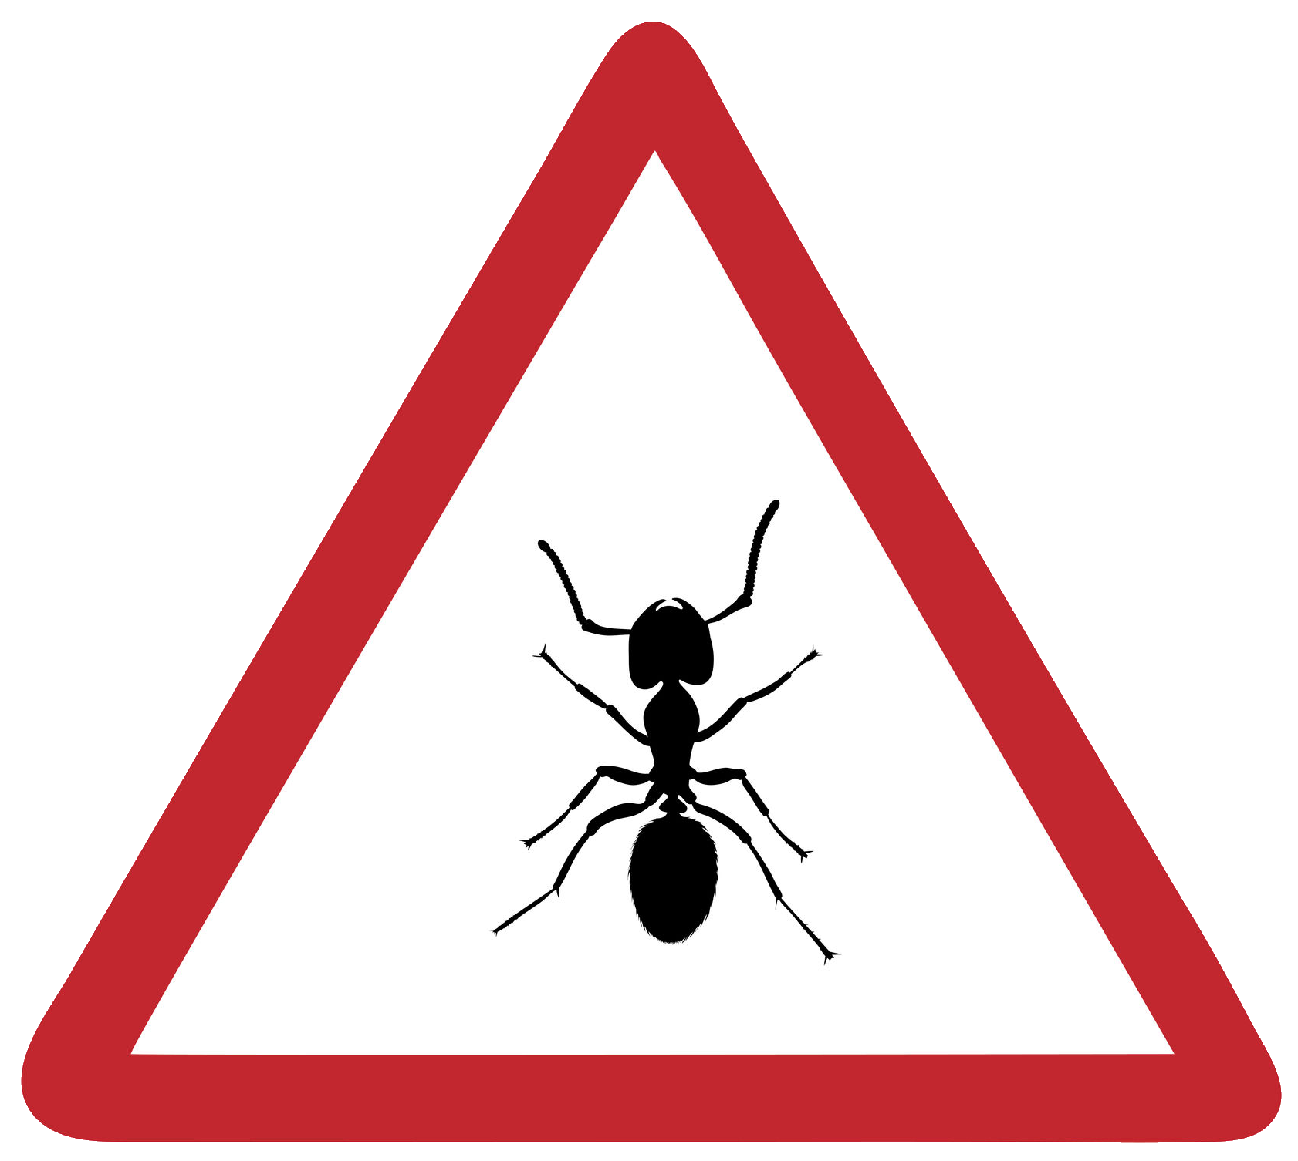 Ant Simulation

C# Theory Questions

These questions refer to the Preliminary Material and the Skeleton Program,
but do not require any additional programming.
TOTAL MARKS: 54

1. The Main procedure in the pre-release program asks the user to enter several pieces of data. One of those is the simulation number.
Currently, the program assumes the user will always enter valid numeric input inside the range
1–4 inclusive.
(a) Explain why this program is not robust when processing user input. [2]
(b) The code contains a prompt on line 20: Enter simulation number:
What error would occur during runtime if the user typed “four” when receiving the prompt
from line 20? [1]
(c) How would a programmer resolve this issue? [1]

2. Give an identifier used for:
(a) A local variable used within the GetCellReference procedure. [1]
(b) A class variable. [1]
(c) The loop counter variable used when nests are being created within the constructor of the Simulation class. [1]
(d) A variable that is used to store the neighbouring cell indices as a list. [1]

3. This program makes use of Encapsulation.
(a) Explain what encapsulation means in object-oriented programming. [2]
(b) Describe how this concept is used within the Cell class. [2]

4. This program makes use of Inheritance.
(a) Explain what inheritance means in object-oriented programming. [2]
(b) Give an advantage of using this technique. [1]
(c) Explain how inheritance is used between the Entity, Ant, and WorkerAnt classes. [2]

5. What data structure is used to represent the grid of cells, and how many elements does it
contain in Simulation 3? [2]

6. Describe how the AdvanceStage methods demonstrate polymorphism. [2]
7. Explain how the simulation demonstrates the use of abstraction by modelling, and state one advantage of using this technique to simulate the behaviour of ant colonies. [3]

8. The simulation stores all cells in a one-dimensional list/array.
(a) Explain how the private method GetIndex allows the program to work with two-dimensional grid coordinates even though a one-dimensional list is used. [2]
(b) Which index would be returned from a call to this method with the Row = 2 and
Column = 5 if NumberOfColumns was 5? [1]

9. This question relates to the GetIndicesOfNeighbours method of the Simulation class.
(a) This is a private method. Explain what it means that this method is private. [1]
(b) What would this method return if it were called with Row = 1 and Column = 1 for a 5×5 simulation grid? [2]

10. Describe the movement choice for an ant who is:
(a) A worker ant that is away from their nest and is carrying food. [1]
(b) A worker ant that does not detect any pheromone trails nearby and has no food. [1]
(c) A worker ant that is not carrying food and does detect pheromone trails nearby. [1]
(d) A queen ant in her nest cell. [1]

11. This question is about the public method AdvanceStage inside the Nest class.
(a) For a nest that currently houses 1 queen and 5 workers, how much food will be consumed
by all the ants belonging to this nest when this method is called? [1]
(b) How does the program make sure that a nest cannot have its food level decremented
below 0? [1]
(c) How many ants would be culled by a call to this method for a nest with a FoodLevel of
7 and 10 living ants belonging to it? [1]
(d) How many ants would be culled by a call to this method for a nest with a FoodLevel of
70 and 10 living ants belonging to it? [1]
(e) Describe the process by which ants are created by a call to this method for a healthy nest
with plentiful food for all the ants. [3]
(f) When the program removes an ant in this method using Ants.RemoveAt(RPos); where
RPos is a random index, what is the time complexity of this operation in Big-O notation,
and why? [2]

12. This question is about the ChooseCellToMoveTo method in the Ant class. This is an abstract method. Describe what this means and how it is used by its subclasses. [2]

13. The program uses random numbers when deciding ant movement and food placement. Explain
why these numbers are not completely random and what determines the sequence generated. [2]

14. The Pheromones in the program are currently stored in a list in the Simulation class. A programmer suggests using a dictionary instead, where the key is the cell coordinates as a tuple and the value is a list of pheromones in that cell.
(a) State one advantage of using a dictionary for this purpose. [1]
(b) Explain why the coordinate pair used as a dictionary key must be hashable. [2]

15. This program has been written using the object-oriented programming (OOP) paradigm.
Explain two differences between the object-oriented and procedural programming paradigms.
In your answer, you should refer to examples from this program to support your explanation. [4]

END OF QUESTIONS

